 

# GHARDA FOUNDATION

**GHARDA INSTITUTE OF TECHNOLOGY, LAVEL**

#### Department of Computer Engineering

**Evaluation Sheet**

Class: TE-Computer Engineeing Sem: V Subject: **Computer Networks**

#### Experiment No: 4

#### Title of Experiment: [Study](https://drive.google.com/file/d/1uQMn8WeCWn0VEWeEtmYb4FUtzgDM8wVN/view?usp=sharing) of Static routing

#### Name of Student: Harvande Sanket Chandrashekhar Roll No: 19

|  |  |  |  |
| --- | --- | --- | --- |
| Sr. No. | Evaluation Criteria | Max Marks | Marks Obtained |
| 1 | Practical Performance | 8 |  |
| 2 | Oral | 5 |  |
| 3 | Timely Submission | 2 |  |
|  | Total | 15 |  |

Signature of Subject Teacher (Mr. S. S. Tathare)

#### **Aim**: To study [the](https://drive.google.com/file/d/1uQMn8WeCWn0VEWeEtmYb4FUtzgDM8wVN/view?usp=sharing) implementation of static routing in a network.

**Apparatus**: Packet Tracer software

**Procedure**:

1. Configure a network using at-least two switches, two routers and 4 PC.
2. Configure IP addresses of all PCs and the router interfaces using proper rules of classful addressing.

3. Ensure that all the connections turn green which indicate the connections as UP.

4. Check for the connectivity using ICMP ping command, the connectivity fails.

5. Configure static routing on both the routers.

6. Check for the connectivity using ICMP ping command, the connectivity succeeds.

**Screenshots**:

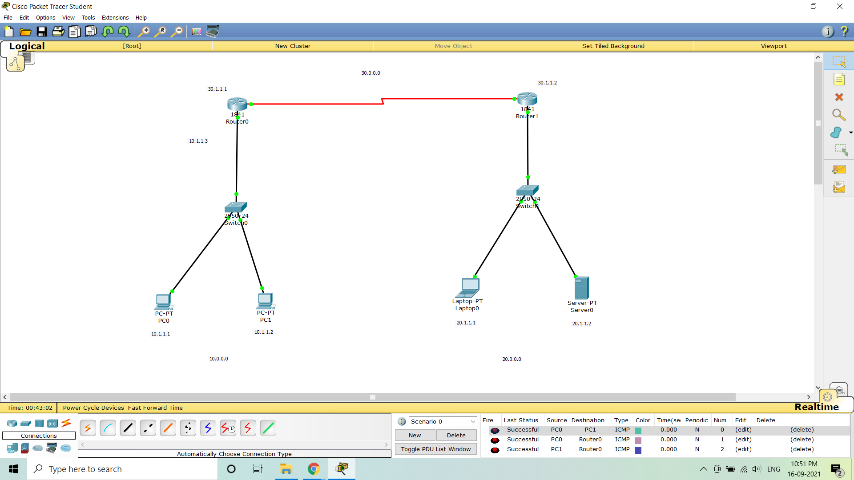

#### **Conclusion**: Thus the study of [the](https://drive.google.com/file/d/1uQMn8WeCWn0VEWeEtmYb4FUtzgDM8wVN/view?usp=sharing) implementation of static routing in a network is done using Packet tracer software.